- System Requirements

- Windows 2000 or above
- Visual Studio 2005 or above
- Sound card
- Speakers
- Microphone
- Network connection

- How to Compile

Create a new Win32 project in Visual Studio 2005 or above. Add the C files, headers, and resource files to the project.

From the Project menu, select Properties. Under Configuration Properties, click the General tab. Change the Character Set to 'Not Set'. Expand the Linker tab and click the Command Line option. Add the following to the list:
- WS2_32.lib
- winmm.lib

You should now be able to compile the project.

- Program Interface

Upon starting the program, you will be presented with the following interface:
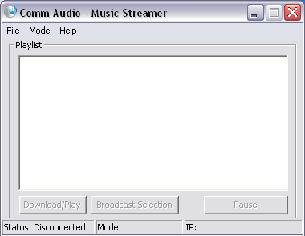

The application can operate in two main modes: Client and Server. Buttons and menu items will be enabled or disabled based on the chosen mode.

- Server

Before hosting a server, it is advised to place your media files in the same directory as your program executable. To start hosting a server, first click on Mode, then on Server.
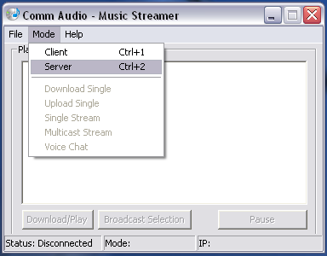
You will be presented with a server dialog with the option to start in Multicast Mode. This mode will allow the server to select the song that will be played, and streams it to all connected clients.
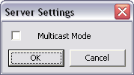
If you do not wish to operate in Multicast Mode, simply press OK without checking the Multicast Mode box. Finally, to start the server, select Connect from the File menu.

If Multicast was selected, the playlist area of the application will be populated with the .wav files located in the same directory as the executable. To start streaming a song in Multicast Mode, select a song, then press Broadcast Selection.
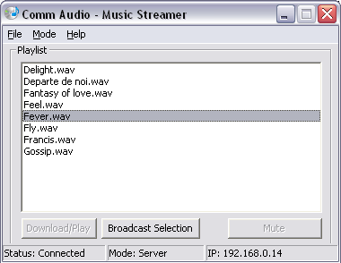
- Client

To start the application in client mode, select the Client option from the Mode menu. Upon doing so, you will be prompted for a server address.
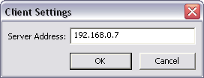

Enter a server address in the field, then press OK.

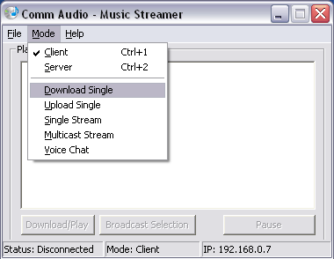
Next, select the transmission method from the Mode menu, then select Connect from the File menu:
Download Single: Displays a listing of .wav files on the server available for download. Selecting a song, then clicking Download/Play will download the selected song to the directory containing the application executable.

Upload Single: Opens a file selection dialog box. Upon selecting a file, the client then uploads the file to the server. Files are uploaded to the directory containing the application executable.

Single Stream: Displays a listing of .wav files on the server available for streaming. Selecting a song, then clicking Download/Play will stream the selected song. The song can be paused at any time by clicking the Pause button.

Multicast Stream: In this mode, the server decides what song is played and when. The client has the ability to mute the song by pressing the Mute button.

Voice Chat: Allows 2-way microphone communication between a client and the server. No other connections are allowed during this mode.

- Local Play

This application also has the ability to play files locally. To do this, first select File, then Play Local File. You will be presented with a dialog box to select a song to play. The file will automatically start playing once the Open button is clicked.

